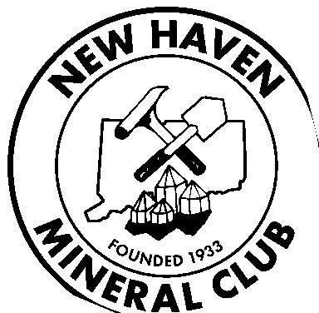**NEW HAVEN MINERAL CLUB**

**newhavenmineralclub.org**

**MEMBERSHIP APPLICATION**

**PLEASE PRINT LEGIBLY**

Name:

Address:

For Family Membership, list names:

Phone Numbers:

Home: ( ) Mobile: ( )

E-mail:

To confirm your E Mail Address, Please send an E Mail. To: president@newhavenmineralclub.org

Other club affiliations: ________________________

Interests: (check all appropriate)

|  |  |  |  |  |
| --- | --- | --- | --- | --- |
| ◻ Minerals | ◻ | Fossils ◻ | Thumbnails ◻ Micro | ◻ Geology |
| ◻ Jewelry | ◻ | Lapidary ◻ | Faceting ◻ Cabochons | ◻ Other: |

Interested in Field Trips? Locations:

**Article XII – Liability**

**Bylaws of the N.H.M.C. (June, 2013)**

**All members and others participating in any activities of the NHMC, do so at their own risk and are responsible for any personal or property damage which may occur to themselves. Acceptance of membership in the New Haven Mineral Club is acceptance of this section and its responsibilities.**

Date of Application: Applicant Signature:

Dues Paid: Treasurer: Date: ________________

**NHMC Dues: (Individual: $20.00) (Family: $25.00)**

**Please Make Check Payable To: New Haven Mineral Club**

**Send Application and Payment To:**

**Treasurer 35E Flintlock Road Ledyard CT 06339**

January 2025