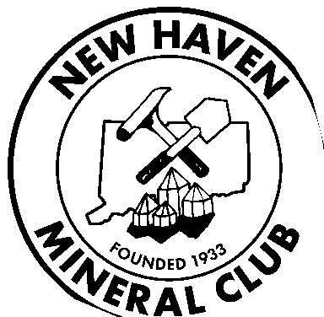**NEW HAVEN MINERAL CLUB**

**newhavenmineralclub.org**

**MEMBERSHIP APPLICATION**

Name:

Address:

For Family Membership, list names:

Phone Numbers:

Home: ( ) Work: ( ) Mobile: ( ) E-mail:

Help the Club reduce Postage Fees;

May we send your Monthly Bulletin to your e-mail address? **(y/n)**

Other club affiliations: ________________________

Interests: (check all appropriate)

|  |  |  |  |  |
| --- | --- | --- | --- | --- |
| ◻ Minerals | ◻ | Fossils ◻ | Thumbnails ◻ Micro | ◻ Geology ◻ Junior Club |
| ◻ Jewelry | ◻ | Lapidary ◻ | Faceting ◻ Cabochons | ◻ Other: |

Interested in Field Trips? Locations:

Interested in participating in club activities? What kind?/Ideas:

**Article XII – Liability**

**Bylaws of the N.H.M.C. (June, 2013)**

**All members and others participating in any activities of the NHMC, do so at their own risk and are responsible for any personal or property damage which may occur to themselves. Acceptance of membership in the New Haven Mineral Club is acceptance of this section and its responsibilities.**

Date of Application: Applicant Signature:

Dues Paid: Treasurer: Date: ________________

**NHMC Dues: (Individual: $20.00) (Family: $25.00)**

**Please Make Check Payable To: New Haven Mineral Club**

**Send Application and Payment To:**

**Treasurer 35E Flintlock Road Ledyard CT 06339**

March 2024