NEW HAVEN MINERAL CLUB
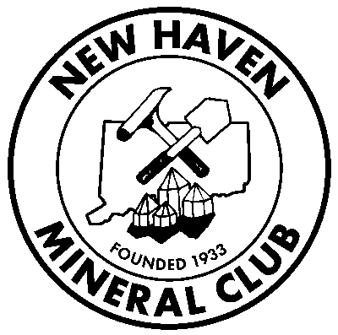
MEMBERSHIP APPLICATION

Name:
Address:

Phone Numbers: NewHavenMineralClub.org

Home: ( ) Work: ( ) Mobile: ( )

Email: May we send your monthly newsletter to your email address? (y/n) 1. The Club needs to cut operating costs on postage
2. Helps the Club’s Green Initiative (see website: Initiatives -Coming Soon)

For Family Membership, list names:

Other club affiliations:

Interests: (check all appropriate or yes/no)
◻ Minerals ◻ Rocks ◻ Fossils ◻ Jewelry ◻ Faceting ◻ Junior Club
◻ Cabochons ◻ Polishing ◻ Thumbnails ◻ Micro ◻ Other:

Interested in Field Trips? Locations:

Interested in participating in club activities? What kind?/Ideas:

Willing to serve on a committee? ----We will accommodate your time:

Willing to serve as an officer?

Article XII – Liability
Bylaws of the N.H.M.C. (February, 1984)
All members and others participating in any activities of the NHMC, do so at their own risk and are responsible for any personal or property damage which may occur to themselves. Acceptance of membership in the New Haven Mineral Club is acceptance of this section and its responsibilities.

Date of Application: Applicant Signature:

***************************************************************************************
Dues Paid: Treasurer: Date:

Membership Committee Approval: Date:

NHMC Dues: (Individual: $15.00) (Family: $20.00) (Student: $6.00)

Please send application to:
Treasurer New Haven Mineral Club 246 Mirror Lane Guilford, CT 06437

